IT3037C Final Exam

This final project (on AWS) will be open book and is worth 10% of your final grade. You will measure and compare the performance of a static web page hosted in S3 with a web page hosted on an EC2 instance using Docker and Apache webserver. In Lab 1, you have learned AWS CLI and EC2 instances. Also, you have learned how to host a web site using an EC2 instance and Apache web server in a Docker container. In Lab 2, you have learned S3 and how to host a web page (a static website) in S3. In the auto-scaling lab, you have learned an Apache HTTP server benchmarking tool, ab. You will use all you have learned to complete this project individually.

Requirements and notes

Remember where your credentials are located. You should have configured AWS under the the home directory of your ubuntu VM. Make sure you know where you ‘pem’ keypair file is located.

This exam makes a number requests to AWS services. Beware that if your run these
commands many times you could go over your monthly quota. Work
smart and carefully.

Verify that your site is accessible by trying to reach the index page or content in the S3 bucket. If you cannot see this in your browser do not issue the ab test.
You must include your full steps and output for the project. Failure to do so will result in the question being marked wrong!

- The static web page you need for this exam is as follows: You must create a website in EC2 using Docker and Apache webserver and compare this versus a static website hosted in S3.

<html><body><h1>It works!</h1>
<p>(Your name) here has hosted this website using AWS and docker</p>
</body></html>

You can name it index.html.
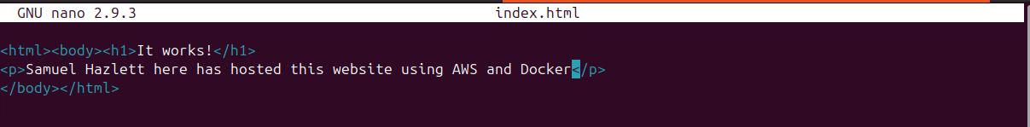

- You need to host this web page on an EC2 instance using Apache webserver in a container and in S3 bucket.


- You need to use the ab command to conduct performance tests. For the EC2 hosting, you need to conduct five ab tests on the web page with 50, 100, 200, 300, and 500 simultaneous requests. The number of requests to perform for each test is 500. The five ab test commands are as follows:
ab -c 50 -n 500 the URL of the index.html on an EC2 instance
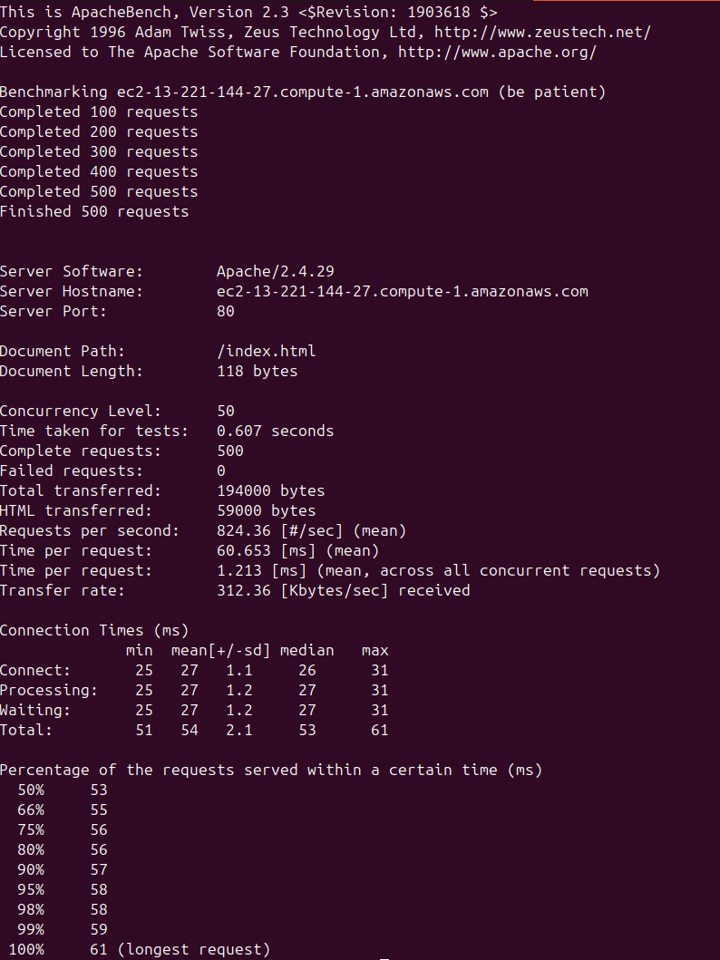
ab -c 100 -n 500 the URL of the index.html on an EC2 instance
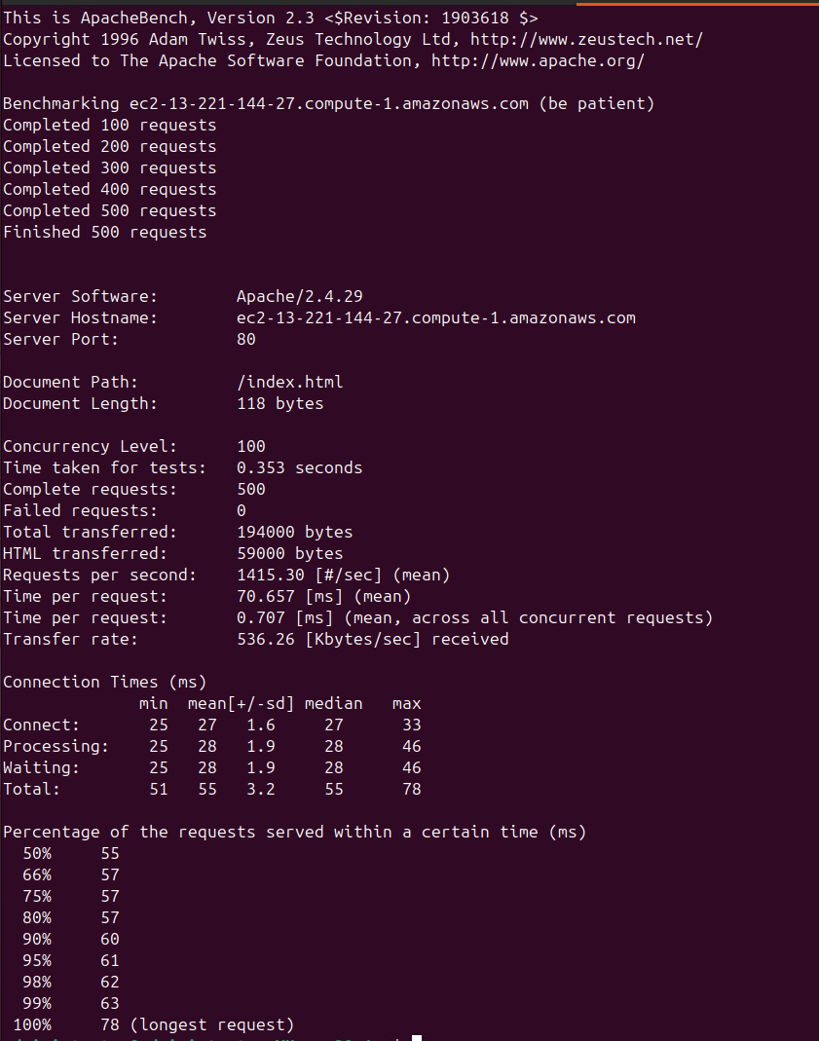
ab -c 200 -n 500 the URL of the index.html on an EC2 instance
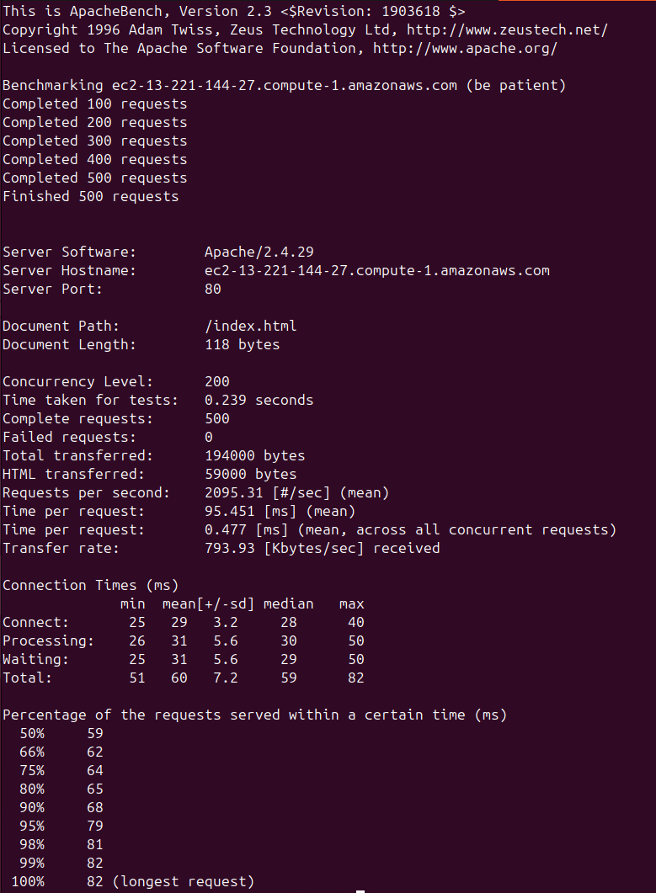
ab -c 300 -n 500 the URL of the index.html on an EC2 instance
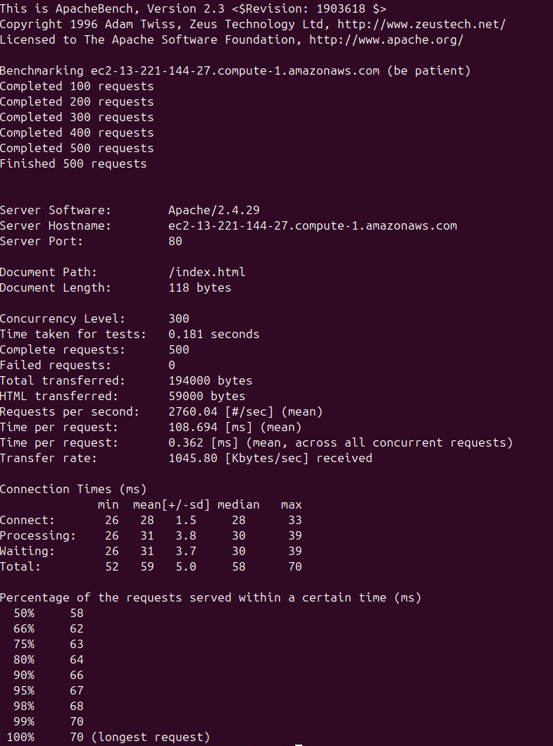
ab -c 500 -n 500 the URL of the index.html on an EC2 instance
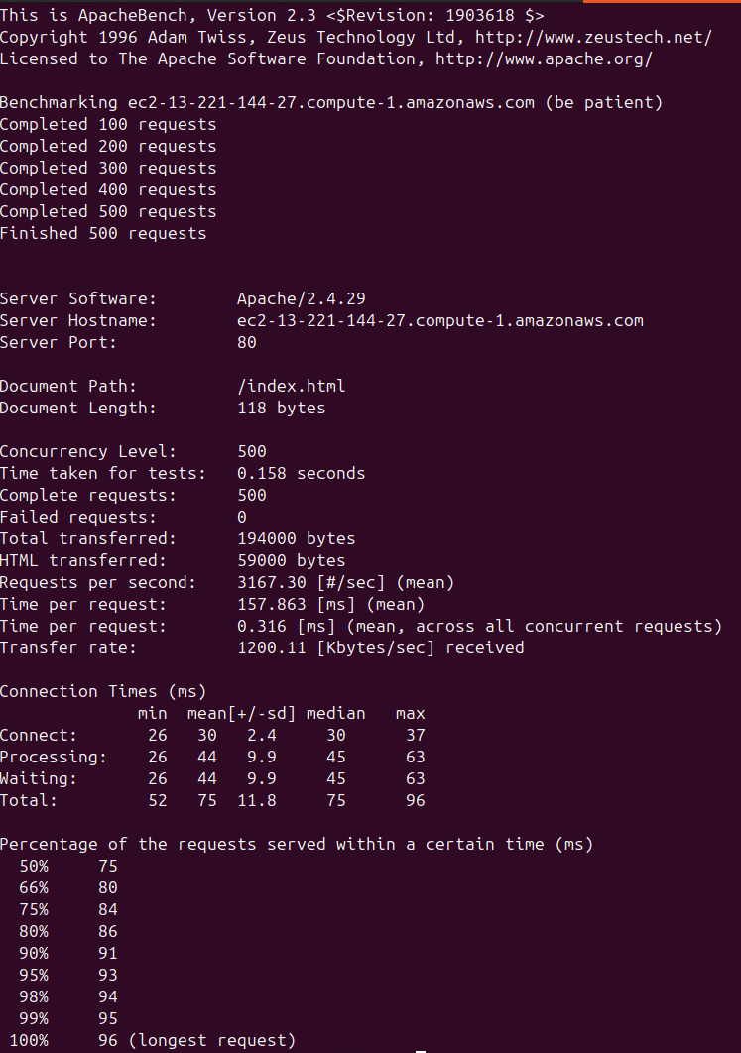

Please look at http://httpd.apache.org/docs/2.2/programs/ab.html for the description of the ab command output. The “Time per request” value is the average time spent per request. There are two “Time per request” values in the output. You need to record the first value for each test.

For the S3 hosting, you also need to conduct five ab tests on the web page with 50, 100, 200, 300, and 500 simultaneous requests. The number of requests to perform for each test is 500. The five ab test commands are as follows:
ab -c 50 -n 500 the URL of the index.html in S3
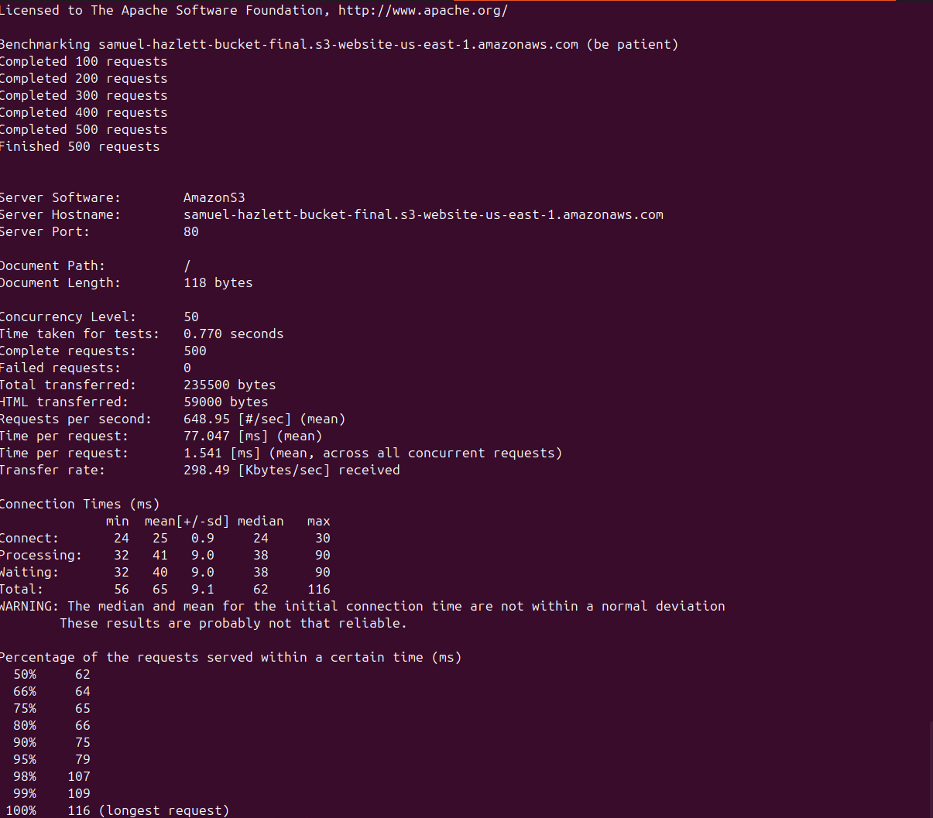
ab -c 100 -n 500 the URL of the index.html in S3
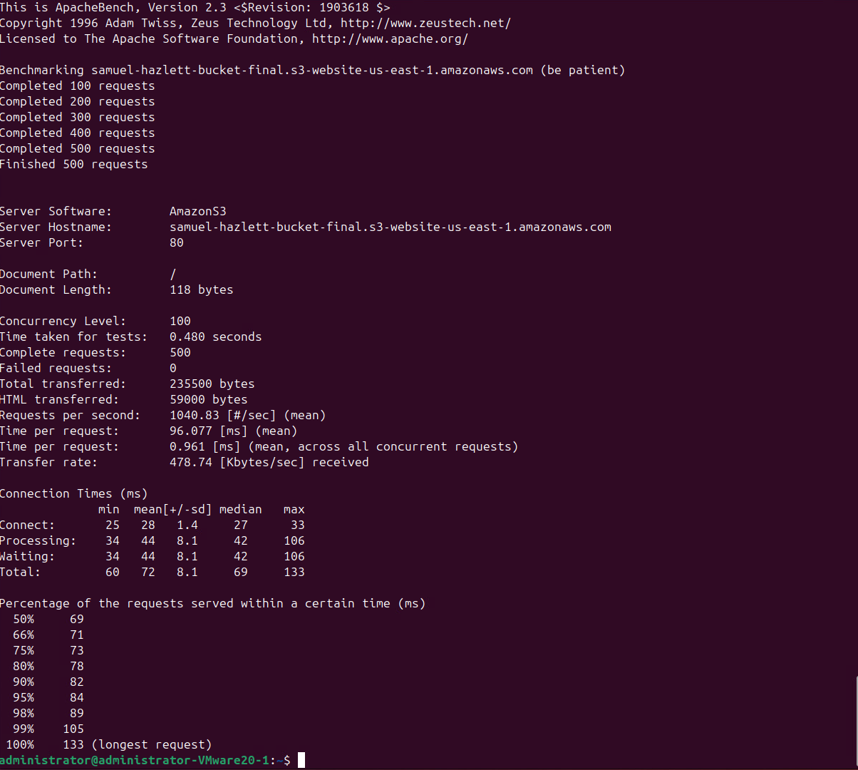
ab -c 200 -n 500 the URL of the index.html in S3
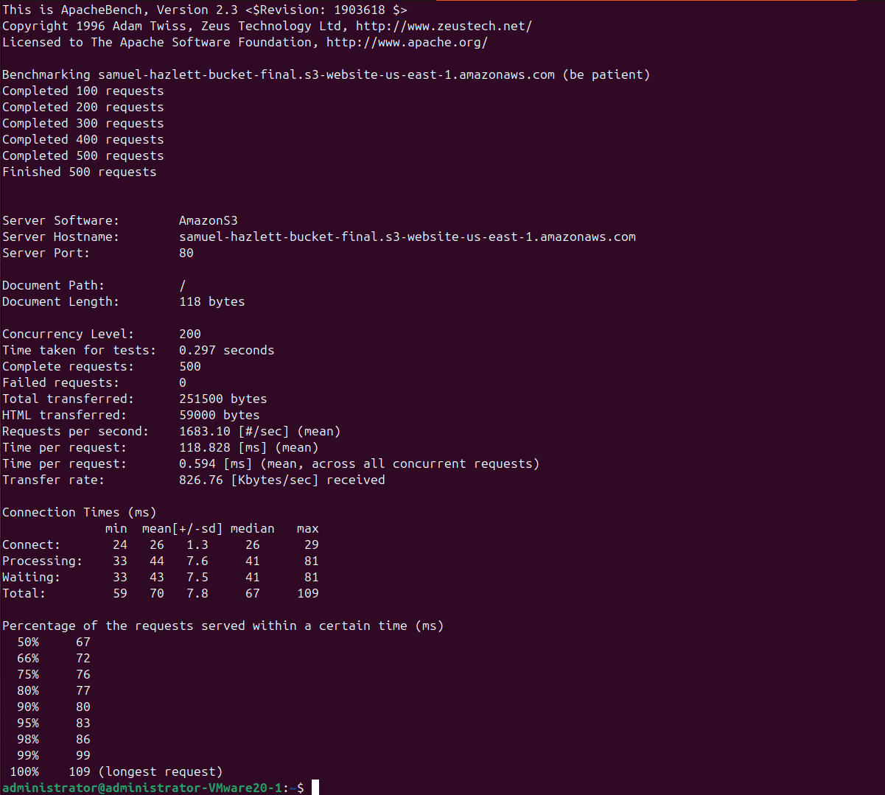
ab -c 300 -n 500 the URL of the index.html in S3
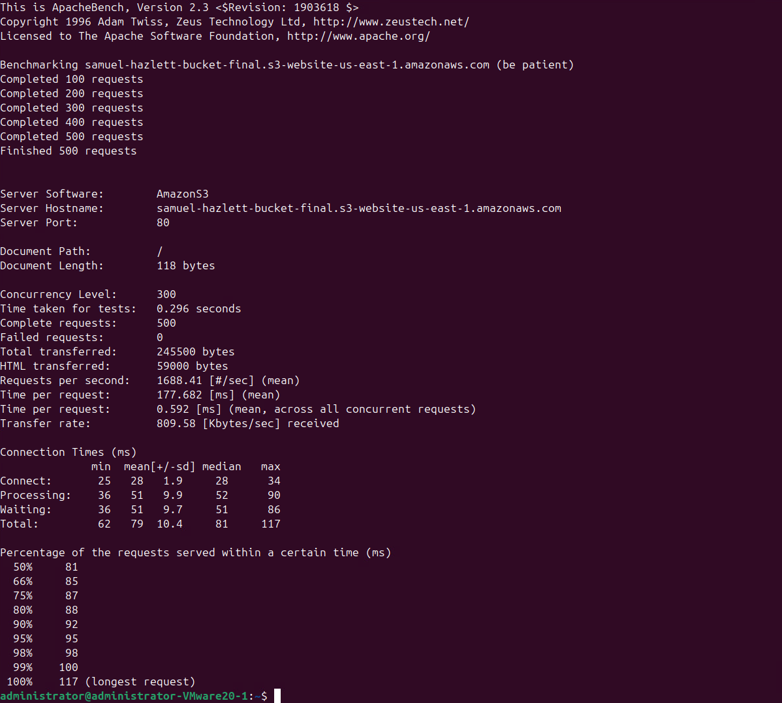
ab -c 500 -n 500 the URL of the index.html in S3
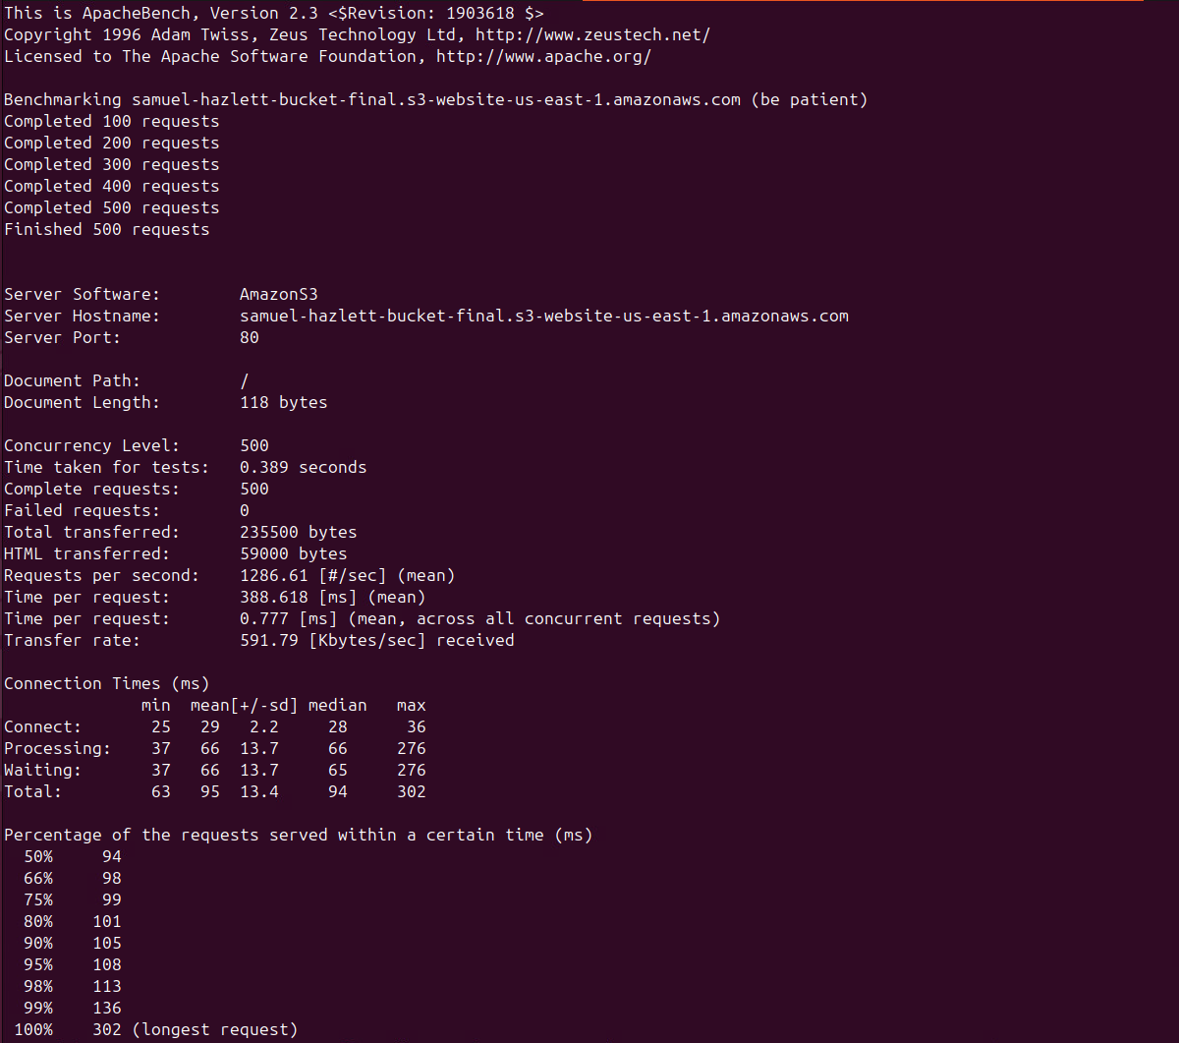
You need to record the “Time per request” value (the first value) for each test.

You need to store data obtained from your tests in a table. Based on the data, you need to plot a graph to compare the performance of the index.html page hosted in S3 with the index.html page hosted on an EC2 instance at different numbers of simultaneous requests. Also, you need to analyze the graph.
Concurrent Users | EC2 Time per Request (ms) | S3 Time per Request (ms)
50 | 60.653 | 77.047
100 | 70.657 | 96.077
200 | 95.451 | 118.828
300 | 108.694 | 177.682
500 | 157.863 | 388.618
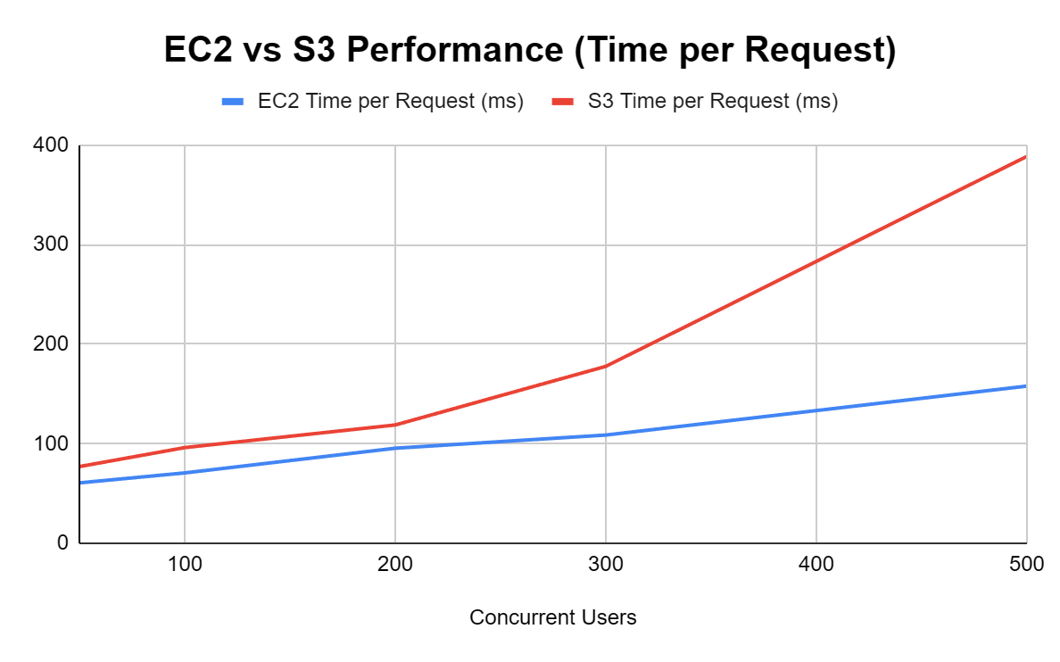

- Using the price calculator at https://calculator.aws/#/ You can make an assumption on the daily usage of the static web site (storage usage, network usage, and computation usage) so that you can compute the cost.
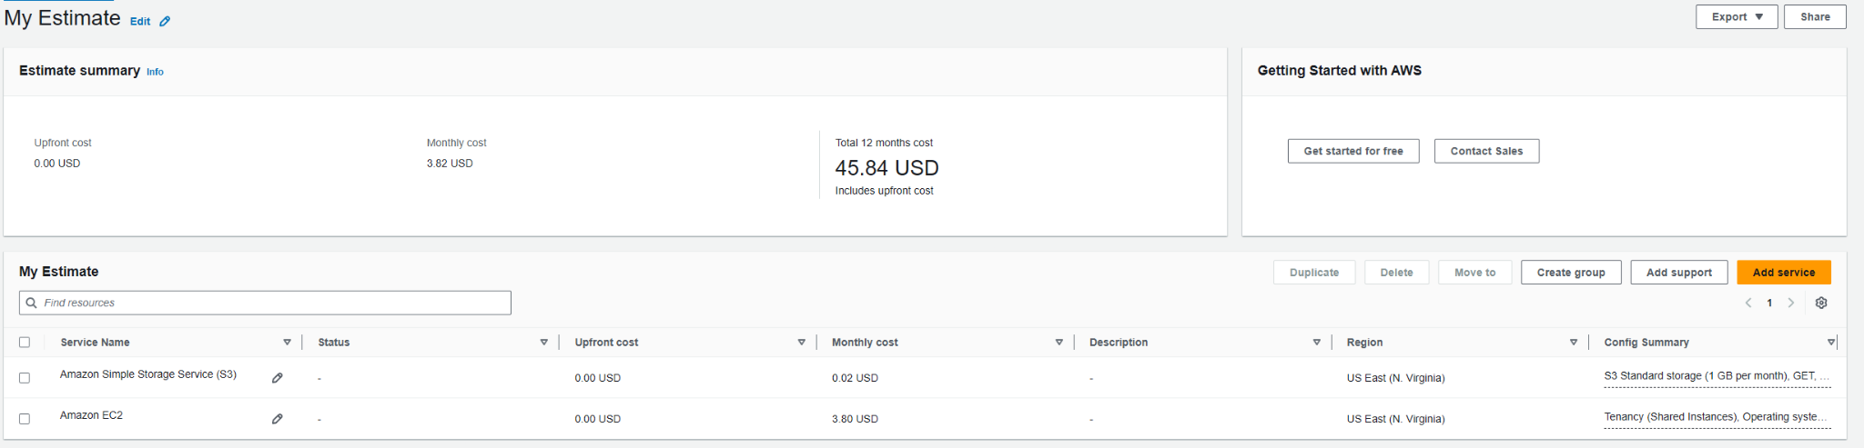

BONUS (10 points): If you would like to try and earn bonus points host your web page in NGINX using a container that deploys your web server for public access. Benchmark this test case and graph the results similarly to compare performance.

Report
For this exam, you need to turn in a report in a word document to the Canvas. The report must include all of the sections listed below:

1. Title Page containing the title of the exam, your name, the name of the class, your instructor's name, and the date the exam was submitted.
2. Introduction A single paragraph that describes the objectives or purpose of the exam.
3. Materials List all materials used in the exam, including AWS CLI, VM, EC2 images, instances, security credentials, and S3 buckets.
4. Methods Describe the steps completed during your investigation. Be sufficiently detailed so that anyone could read this section and duplicate your efforts. Write it as if you were given direction for someone else to do the exam.
5. Data Numerical data obtained from your procedure presented as a table. Data encompasses everything recorded when you conducted the experiment, without any interpretation of what they mean.
6. Performance Analysis Describe in words and a graph what the data means. This is the section where you interpret the data. Label your graph with a descriptive title and label the axes, including units of measurement.
7. Economic Analysis Describe in words and a table/a graph the differences in cost between the two solutions. Your analysis should include answers to the questions: Which solution for static web site hosting is cheaper? Is the cheaper alternative faster or slower than the more expensive solution?
8. Conclusion A short summary of the experiment, including its purpose and the meaning of your results. Advise the reader on which web hosting solution to use.
9. References List any references that you used during your exam.

